Listed Fixes needed for Report Builder 7.0

1. Start of Report
Summary flyer sheet doesn’t build, it builds the title page - FIXED
The Title page is labeled summary - FIXED
2. End of report
Move CAR to the end - FIXED
3. Inlet/Outlet Sheet
Ducted REUTN inlet sheet – FIXED
Location Field auto populates. - FIXED
4. RTU/AHU
Why when N/A selected does return inlets not go black on RB? - FIXED
5. ERV IGNORE ALL TIL LATER
Need to black out return cells on RB for ERV
Traverses need to be renamed for OA and EA only
Can the ERV Exhaust data sheet populate after the ERV Supply data sheet?
Exhaust inlet sheet adds data in the sheets cell (Crazy look at this)
11. EF
All Exhaust air traverses indicate return not exhaust at the top FIXED
The exhaust inlet sheet populates as return inlets. FIXED
12. CT
Delete cell reference for Area Served FIXED
Design water data fields must be deleted or blacked out on RB FIXED
Cell reference’s are incorrect on sheet for air and water data FIXED
13. Boiler
Should the title block be Gas Burner or Heating Element, or something else? – IGNORE THIS RC TO FIX
Delete cell reference for Area Served FIXED
Cell references are incorrect on pressure and GPM, need to fix on RB as well FIXED
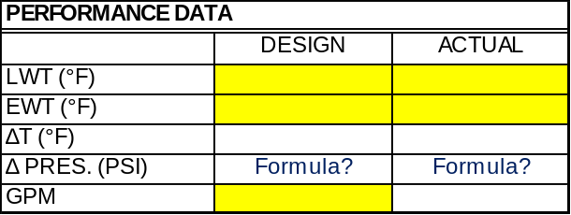
15. Row 177 has a height of 4 pixels as compared to the standard 25 pixel height. This error is hard to see and could cause someone to miss inputting information. This error was observed once inputting the number of RTU's and after generating the outlet/inlet sections. COULD NOT REPLICATE, IF HAPPENS AGAIN SCREENSHOT IT

16. Also, when inputting number of inlets for RTUs, if some of them have zero inlets and others have 1, 2, etc, if you put zero in for the first RTU it will not populate any RTU inlets to input for the rest of the RTUs.
NEED TO FIX MISMATCH ERROR – JUST VISUAL NOT FUNCTIONAL
RTU 2 FIXED
AHU 2 FIXED
FCU 2 FIXED
Ask:
AC 1 FIXED
CRAC 1 FIXED
FAN 1 FIXED

17. Adding to this: misspelled air terminal unit on this latest version as well. FIXED
18. 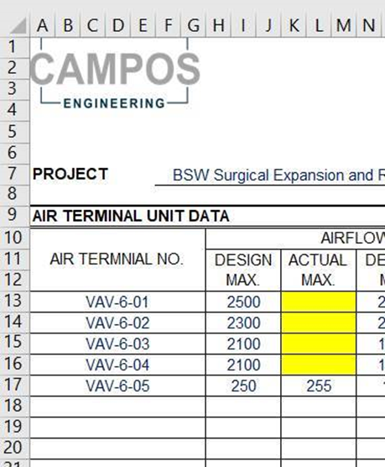

19. Fan template has 1765 as design motor rpm - FIXED
20. Why can’t we select --- for fan rotation design FIXED
AHU – mainmt - FIXED
RTU – mainmt - FIXED
FCU - FIXED
AC - FIXED
CRAC - FIXED
FANMT - FIXED
21. Ahu, fan etc show CRT. NAME AMPS (no period), while FULL LOAD AMPS. (Shows period after AMPS) FIXED
22. Table of contents uses “Air Handler Unit Systems Test Reports” when all other language including flyer sheet uses “ing” as in “Air Handling Unit Systems Test Reports”. - FIXED
23. Clicking “diagnostic” in report builder does not give a diagnostic cover page – FIXED
24. HHW Coil summary pulls the clg. max cfm in lieu of the htg max cfm. Elec heat is working properly, for reference. COULDN’T REPLICATE, FOLLOW UP IF STILL AN ISSUE
25. Remove the primary air setpoint text box from our VAV, DDVAV, and Air Valves. FIXED
26. Large pitot tube traverse optional RC TO PROVIDE SHEET TO DIRK
27. Drew to change font color for fan
28. ? Link the total MBH cell of to the side of the CHW/HHW summary to the actual MBH field in the document FIXED
29. Remove password references for protection and unprotection in VBA FIXED

